Adf pipeline

1.use foreach
Created one parameter called loop_input:
[{"schema":"dbo","table":"DimUser","cdc_col":"updated_at","from_date":""},{"schema":"dbo","table":"DimTrack","cdc_col":"updated_at","from_date":""},{"schema":"dbo","table":"DimDate","cdc_col":"date","from_date":""},{"schema":"dbo","table":"DimArtist","cdc_col":"updated_at","from_date":""},{"schema":"dbo","table":"FactStream","cdc_col":"stream_timestamp","from_date":""}]
Items: @pipeline().parameters.loop_input
Inside foreach used lookup called last_cdc:
Created one dataset called Json_dymanmic
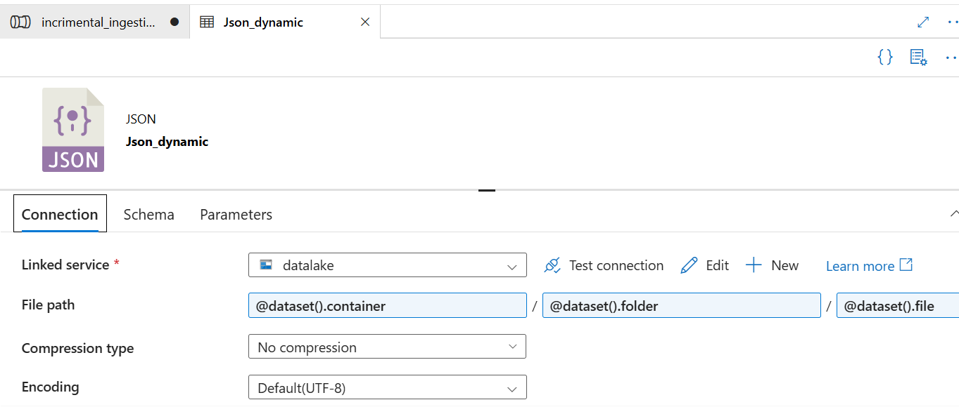
For last_cdc settings:

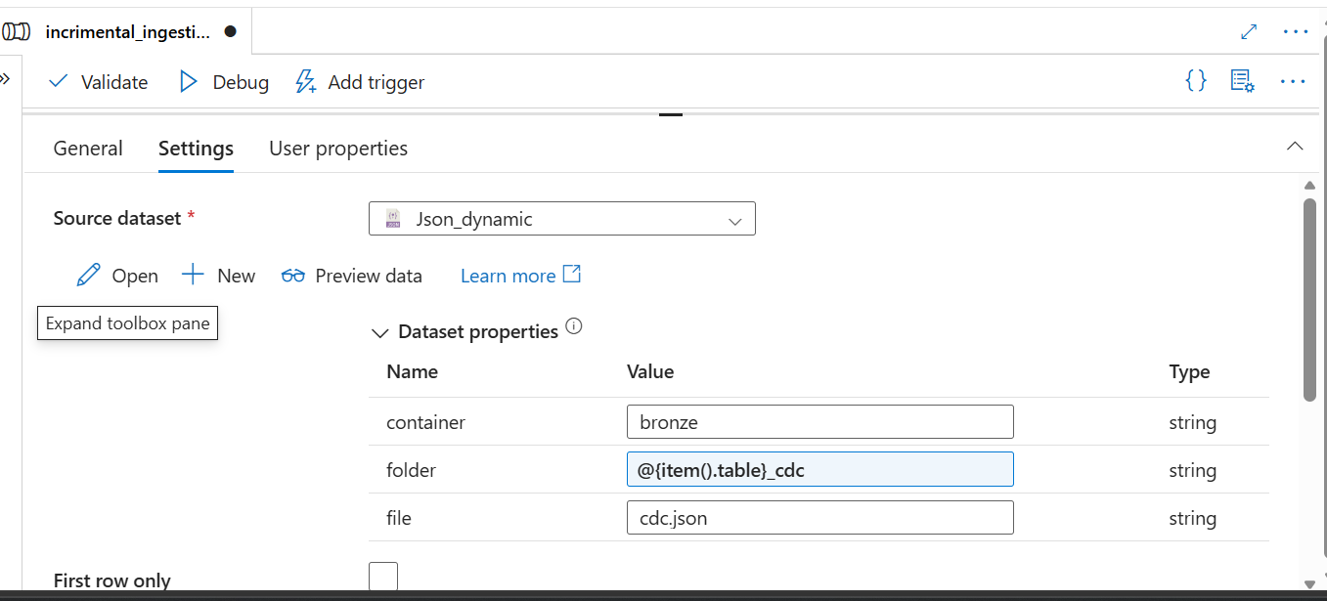
We use copy data connect to last_Cdc:
Copy data name is AzureSQLTo Lake
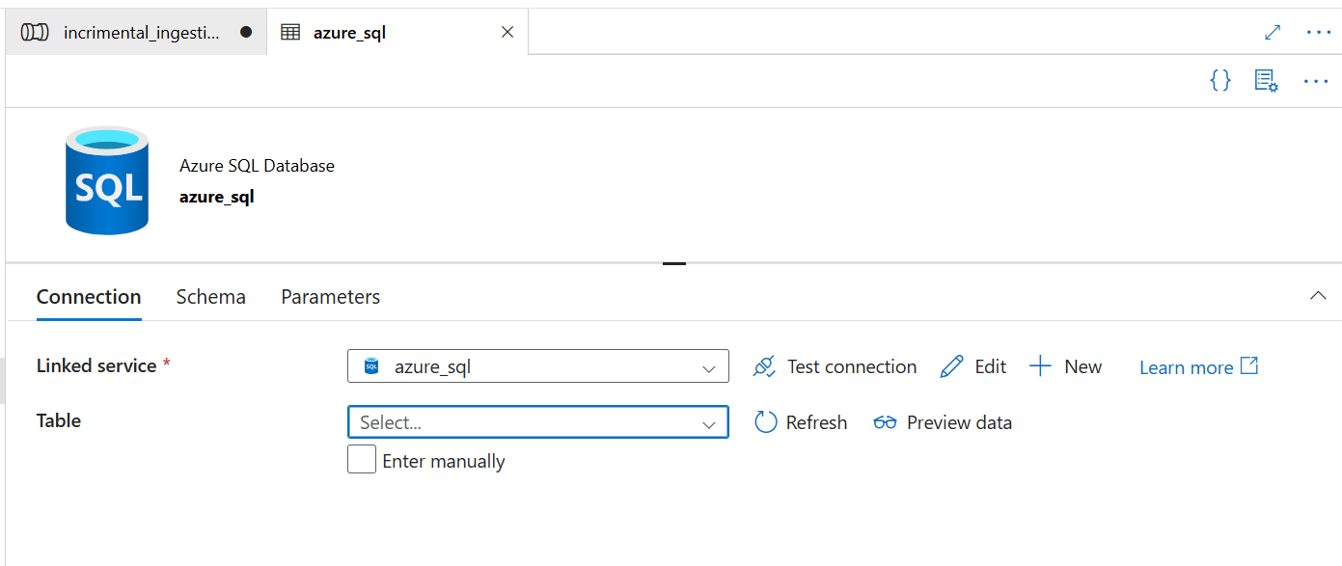
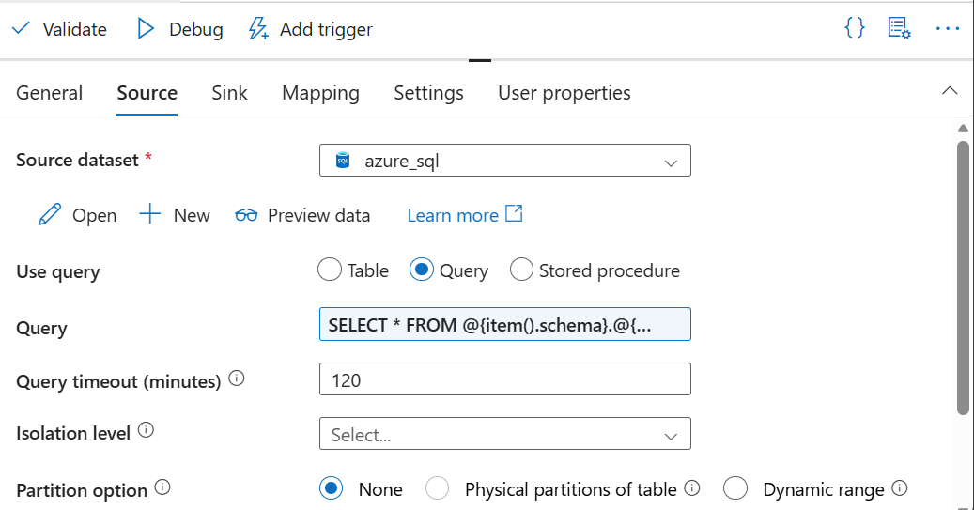
SELECT * FROM @{item().schema}.@{item().table} WHERE @{item().cdc_col}>'@{if(empty(item().from_date),activity('last_cdc').output.value[0].cdc,item().from_date)}'

Sink:
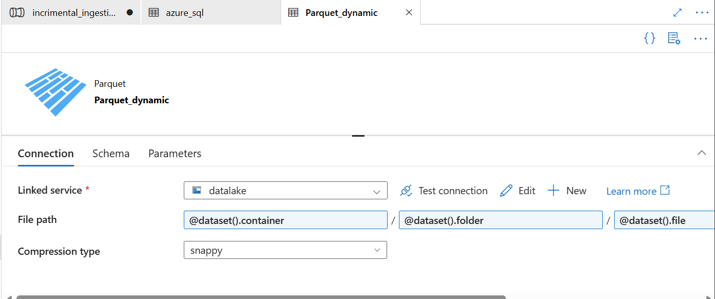
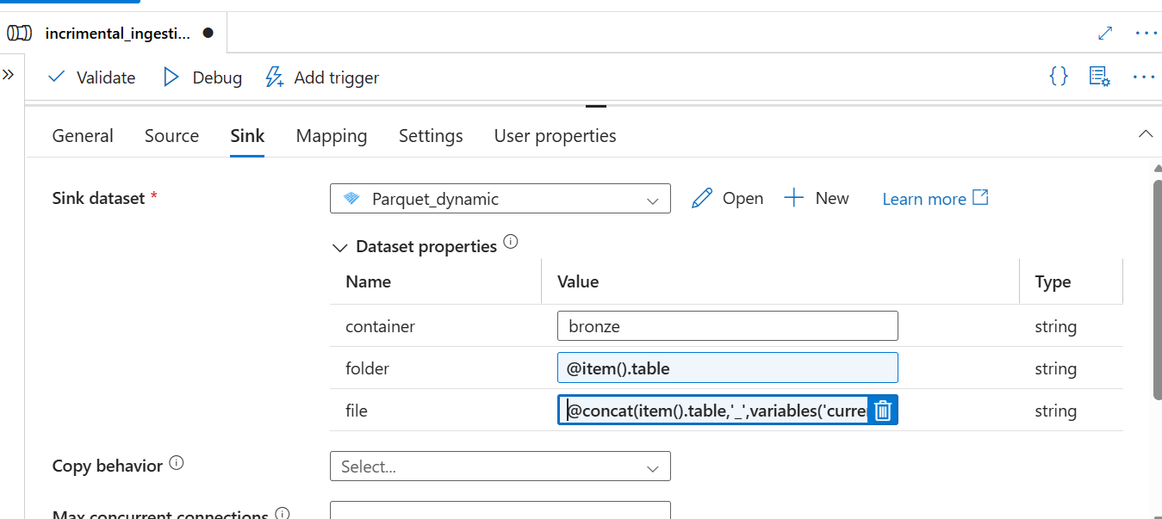
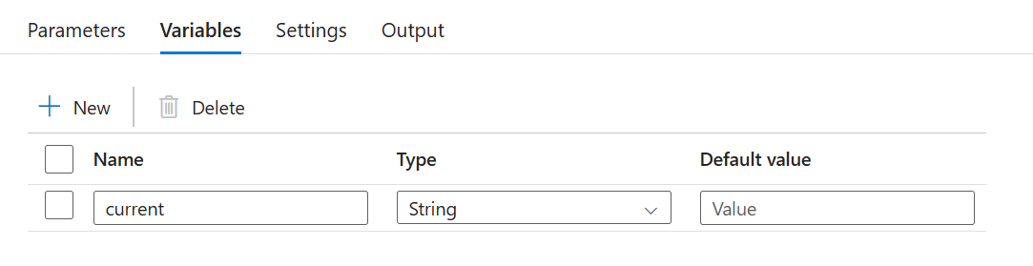
@concat(item().table,'_',variables('current'))
Then next:
Use if else:
Name is ifincrimentaldata
Expression:
@greater(activity('AzureSQLTo Lake').output.dataRead,0)
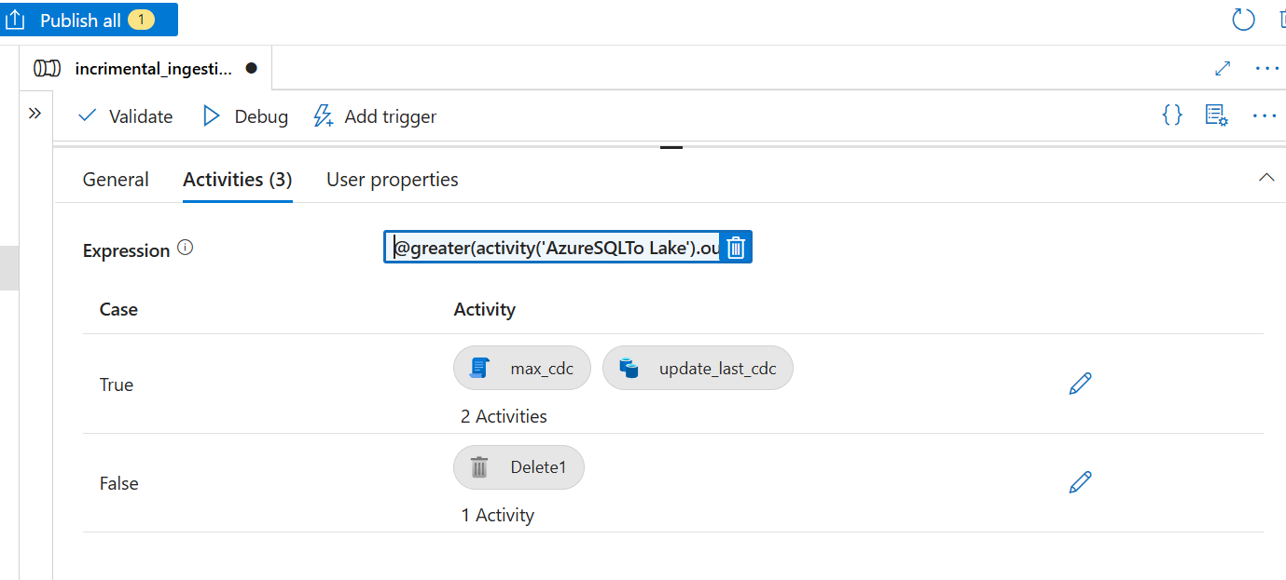
True:
Max_cdc:
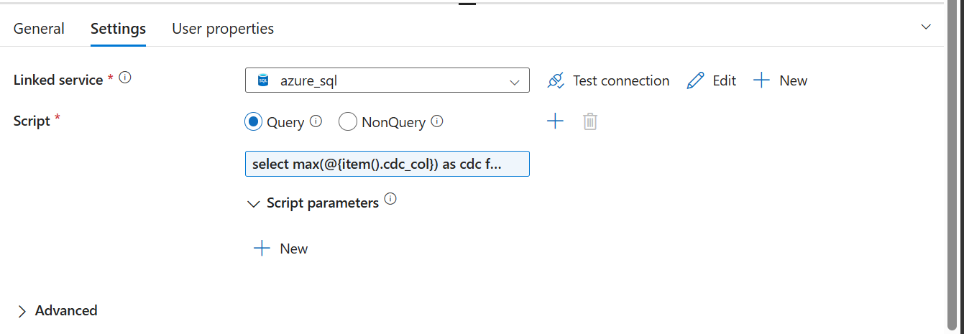
select max(@{item().cdc_col}) as cdc from @{item().schema}.@{item().table}
coonect to copy data:
update_last_cdc
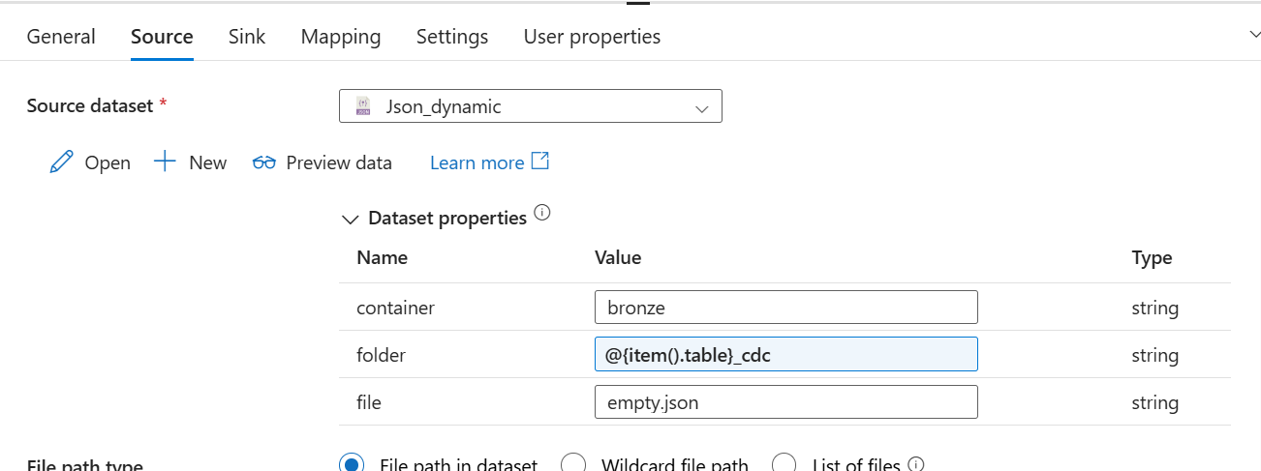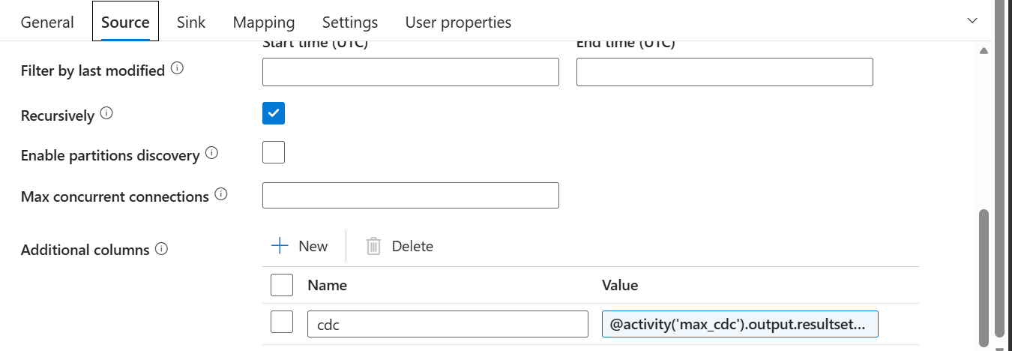
@activity('max_cdc').output.resultsets[0].rows[0].cdc

Sink :
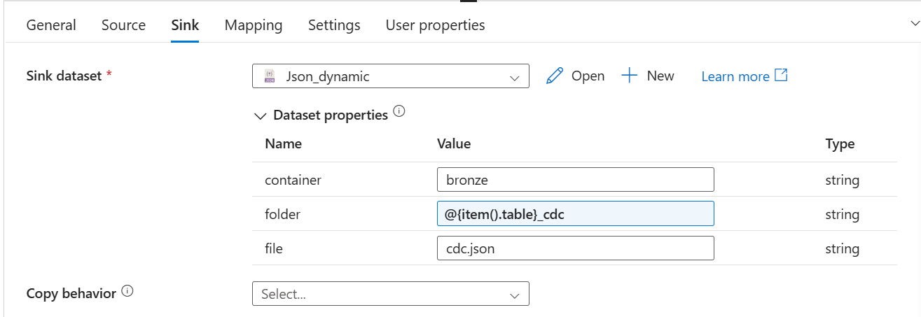

FALSE:

DELETE activity:
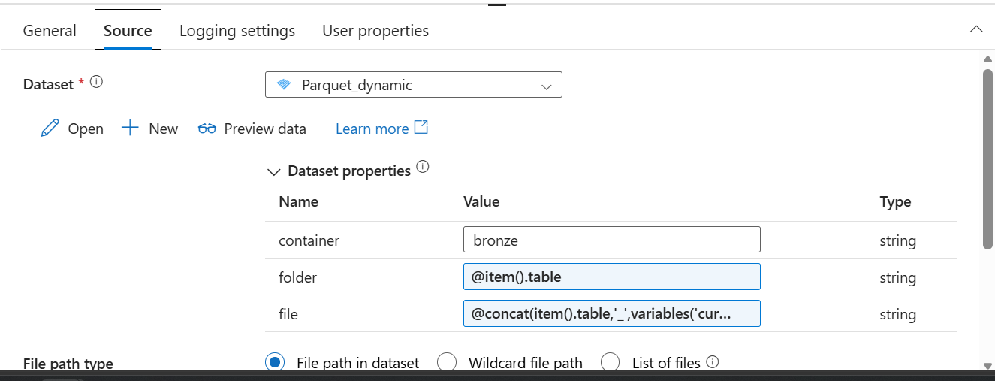
@concat(item().table,'_',variables('current'))

Then use web connects to foreach:
Name:alerts
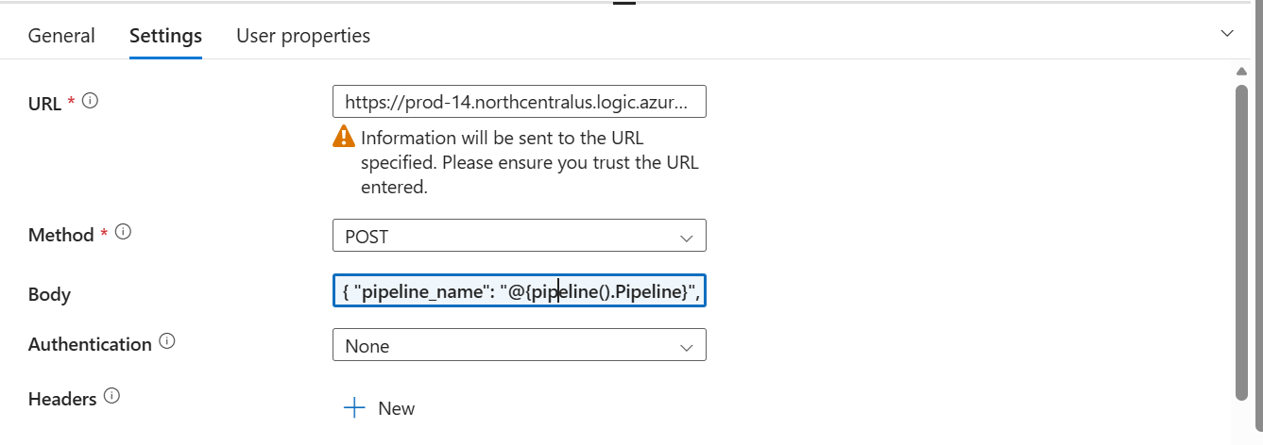
{
"pipeline_name": "@{pipeline().Pipeline}",
"pipeline_runId": "@{pipeline().RunId}"
}

Total pipeline:
